Project Design Phase-II
Data Flow Diagram & User Stories

Date | 27 June 2025
Team ID | LTVIP2025TMID41917
Project Name | Smart Sorting: Transfer Learning for Identifying Rotten Fruits and Vegetables
Maximum Marks | 4 Marks

Data Flow Diagrams:
A Data Flow Diagram (DFD) is a traditional visual representation of the information flows within a system. A neat and clear DFD can depict the right amount of the system requirement graphically. It shows how data enters and leaves the system, what changes the information, and where data is stored.
Example: DFD Level 0 (Industry Standard)
Example: (Simplified)
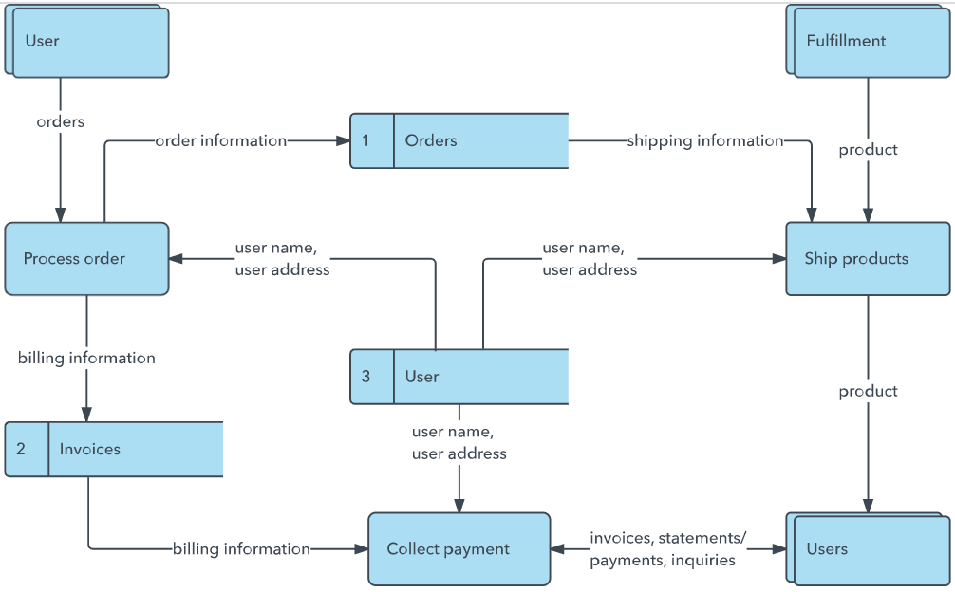


User Stories
Use the below template to list all the user stories for the product.
User Type | Functional Requirement (Epic) | User Story Number | User Story / Task | Acceptance criteria | Priority | Release
Customer (Farmer/Vendor) | Image Capture and Upload | USN-1 | As a user, I can register for the application by entering my email, password, and confirming my password. | I can access my account / dashboard | High | Sprint-1
Customer | View Results | USN-2 | As a user, I will receive confirmation email once I have registered for the application | I can receive confirmation email & click confirm | High | Sprint-1
Operator | Image Upload | USN-3 | As a user, I can register for the application through Facebook | I can register & access the dashboard with Facebook Login | Medium | Sprint-2
Admin | History Tracking | USN-4 | As a user, I can register for the application through Gmail | can register & access dashboard with Gmail login | Medium | Sprint-3
Customer Care Executive | Support Management | USN-5 | As a user, I can log into the application by entering email & password | can successfully login and access the dashboard | Low | Sprint-3
Customer | Login | USN-6 | As a user, I can view a list of scanned fruits/vegetables and their freshness status. | The dashboard displays item names, images, and freshness results | High | Sprint-1
Customer (Web User) | Dashboard | USN-7 | As a web user, I can upload images of fruits/vegetables for quality analysis. | The system uploads image and shows analysis result | High | Sprint-2
Customer Care Executive | Report Management | USN-8 | As a care executive, I can access reports of user scan history and feedback. | I can filter user scans by date or product | Medium | Sprint-3
Administrator | User Management | USN-9 | As an admin, I can manage user roles, block/report accounts if necessary. | I can view, edit or deactivate any user account | High | Sprint-3

